Kalia Institute SCO 184 (Top Floor) Sector 37 C Chandigarh 9815439805,0172-2628742

Work, Energy and Power
Physics

Work Energy Theorm for a particle
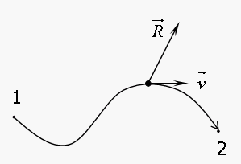

Consider a particle of mass `m’, moving under the action of several forces, having a resultant $\vec{R}$ , in an arbitrary locus. Let it undergo a differential displacement during a time interval dt equal to : $\vec{ds}$ = $\vec{v}$ . dt . Then applying Newton’s Law in the tangential Direction , we obtain:
$\vec{R}$ . $\hat{v}$ = ( $\sum{{\vec{F}}_{i}}$) . $\hat{v}$ = m $\frac{dv}{dt}$ = m. $\frac{dv}{ds}$ . $\frac{ds}{dt}$ = m. v. $\frac{dv}{ds}$
⇒ ( $\sum{{\vec{F}}_{i}}$) . (ds.$\hat{v}$ ) = ( $\sum{{\vec{F}}_{i}}$) . $\vec{ds}$ = m v. dv

